INF 286 Instructor Dr. Seth Adjei
Assignment #5 Last Name: First Name:

Grade:
Comment:

Problem 1 (15%)
Write the CSS for an id, named as logo, with the following attributes (3%):
- Float to the left of the page; (4%)
- Verdana or sans-serif type face font; (2%)
- Large font size; (2%)
- 20 pixels of padding. (4%)
Please write your code directly here in the WORD document.

#logo { float: left;
font-family: Verdana;
font-size: large;
padding: 20px;
}

Problem 2 (15%)
Write the CSS for an id, named as rightarea, with the following attributes (3%):
- Absolutely positioned on a page 20 pixels from the top and 40 pixels from the right; (8%)
- Light gray background; (2%)
- Solid border; (2%)
Please write your code directly here in the WORD document.

#rightarea { position: absolute;
top: 20px;
right: 40px;
background-color: light gray;
border-style: solid;
}

Problem 3 (20%)
Create following layout (12% see the picture below, your code display result does not have to be accurate on the pixels/color, but it needs to be similar to the result below):
- Red box is on top of the green box and they overlap with each other partially; (4%)
- Both boxes have solid border which is black and 3 pixel thick; (4%)
- Please save your code as a text file, named as problem3.html.
- Submit this file.

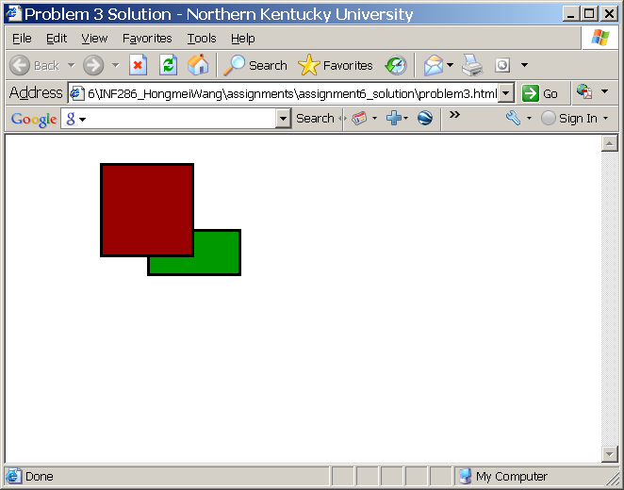

Problem 4 (20%)
Given the picture a.gif, create following layout (see the picture below, your code display result does not have to be accurate on the pixels/color, but it needs to be similar to the result below):
- Please save your code as a text file, named as problem4.tml;
- Submit this file.

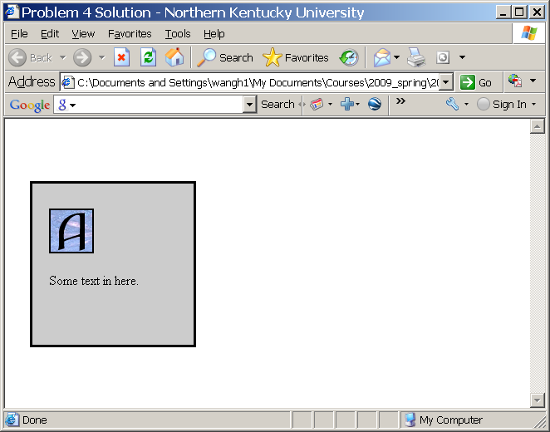

Problem 5 (30%)
Create a web page, problem5.html, about yourself (an example Web page is shown below), and the web page should satisfy the following conditions:
- The web page includes two columns: the left column and the right column (7%);
- The left column is the navigation area, which includes four navigation hyperlinks to four web pages of Short bio, Classes, Favorite web sites, and contact (7%);
- The navigation links should work as required:
  - Do not show list markers and underlines (5%);
  - Have different colors at different states (5%):
    - default as blue;
    - visited as red;
    - hover as green;
    - active as purple;
- The right column includes a header, a content area, and a footer area indicating your copy right:
  - The header shows the text “FirstName LastName’s Homepage”, e. g. Hongmei Wang’s Homepage, and your photo. Your photo is always at the right end of the header area (2%);
  - The content area shows your favorite words (2%);
  - The footer shows Copyright © 20XX FirstName LastName, e. g. Copyright © 2009 Hongmei Wang. The footer text is centered (2%).
- Submit the problem5.html file and your photo image file.
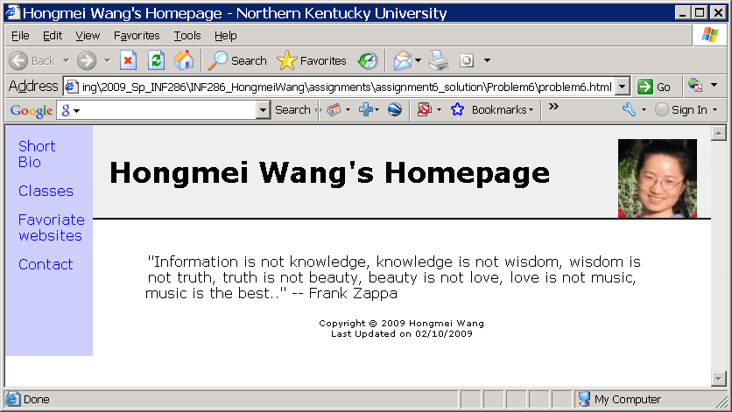

Note:
- Please remember to rename your file as Lastname_Firstname_Assignemtn5.doc.
- Please compress all your files into one file (.zip), including:
  - problem3.html,
  - problem4.html,
  - problem5.html and associated your photo image file and
  - Lastname_Firstname_Assignemtn5.doc;
- Please submit the compressed file, only one file, to the Blackboard.

